**IT Asset Management Software Solution**

**Version:** 3.0  
**Date:** 26- FEB- 2025  
**Prepared by:** [Vinoj Kumar / Meraki Group]

**1. Introduction**

This document outlines the IT Asset Management Software Solution. Software is designed to effectively track, manage, and report IT assets within an organization.

**2. Version History**

| **Version** | **Date** | **Author** | **Remarks** |
| --- | --- | --- | --- |
| 1.0 | 14- FEB- 2025 | Vinoj |  |
| 2.0 | 14- FEB- 2025 | Vinoj/ LIJAS | Field Additions |
| 3.0 | 26-FEB-2025 | Vinoj/ LIJAS | Rearranging Asset Fields |
| 4.0 | 9-April-2025 | Vinoj/ LIJAS | Dashboard Inclusion and Detailing necessary Fields and Values for Reporting |

**2. Requirement Analysis**

The software must provide a centralized system to track IT assets efficiently. Key requirements include:

* Differentiating between **IT Asset Active** (Issued Assets) and **IT Asset Stock** (Unassigned Inventory)
* Ensuring Serial Number uniqueness
* User role-based access for security
* Generating detailed analytical reports
* Exporting and printing asset records in predefined formats

**3. System Architecture**

* **Database:** SQLite / ~~MySQL~~
* **Frontend:** Python Tkinter / ~~Web-based~~
* **Backend:** Python with REST API
* **Security:** Role-based access, Data encryption, Audit logs

**4. System Design / Overview**

The IT Asset Management Software will have an intuitive **drop-down selection** to differentiate between the below at the Main Menu:

1. **IT Asset Active** (Issued Assets)
2. **IT Asset Stock** (Unassigned Inventory)
3. **Dashboard view** (Overview Summary of Active and Stock)

**4.1 User Interface for Filtering Assets**

The software will include a submenu with dropdowns for selecting and filtering assets based on the following fields:

First 14 Fields will be visible by default, balance fields can be made visible using show more.

1. **Company (Meraki, MICL, SALES. EDUCATION, Steel)**
2. **Location (SS7/SS16/Majan)**
3. **Category \***
4. **Status (Active/Stock/Attention)**
5. **Username**
6. **Designation**
7. **Department**
8. **Model**
9. **Description**
10. **Serial Number (Primary Key)** (Unique, cannot be duplicated)
11. **Issue Date**
12. **Computer ID**
13. **Working Status (Working/Notworking/Damage/ Under Maintenance)**
14. **Condition**
15. **Audit**
16. **Employee ID**
17. **Purchase Date**
18. **Rack/Tray Number**
19. **Service Center**
20. **LPO Number**
21. **Invoice Number**
22. **Supplier**
23. **Estimated Cost**
24. **Remarks**

**\* Denotes a Mandatory Field**

**4.2. Reporting Features**

The software will include an option to generate **separate reports** based on the below parameters and be able to export in Excel or PDF using Advanced Search:

1. **Company (Meraki, MICL, SALES. EDUCATION, Steel)**
2. **Location (SS7/SS16/Majan)**
3. **Category \***
4. **Status (Active/Stock/Attention)**
5. **Username**
6. **Designation**
7. **Department**
8. **Model**
9. **Description**
10. **Serial Number (Primary Key)** (Unique, cannot be duplicated)
11. **Issue Date**
12. **Computer ID**
13. **Working Status (Working/Notworking/Damage/ Under Maintenance)**
14. **Condition (New/Good/Fair/Poor)**
15. **Audit**
16. **Employee ID**
17. **Purchase Date**
18. **Rack/Tray Number**
19. **Service Center**
20. **LPO Number**
21. **Invoice Number**
22. **Supplier**
23. **Estimated Cost**
24. **Remarks**

**\* Denotes a Mandatory Field**

**5. Print and Export Options**

The system should allow users to **print reports** and export data in various formats.

1. Depreciation Report
2. Ageing Report
3. LifeCycle
4. Warranty Report
5. Maintenance Report

**Email to EndUser (**The system should allow admins to send email using a predefined email template**)**

* **Excel Templates** for:
  + IT Asset Hardware Issue Form
  + IT Asset Transfer Form
  + MIS Report

**6. Additional Analytical Reports**

To enhance IT department efficiency, the software should provide the following analytical reports and be able to export in Excel or PDF:

* **Asset Depreciation Report** – Track asset value over time.
* **Asset Ageing Report**- Assets older than 3/5/7/10 years.
* **Asset Lifecycle Report** – Identify aging assets requiring replacement older than 5 years.
* **Warranty and Maintenance Tracking** – Ensure timely maintenance.
* **Utilization Report** – Analyse asset usage trends.
* **IT Budget Forecast Report** – Predict future IT asset procurement needs.
* **Compliance and Audit Report** – Monitor adherence to IT governance policies.

**7. Backup**

The software will have an automated daily backup copy generated and retained for 365 days

1. Daily automated backup of entire Asset File.
2. Full Copy Daily Backup of both IT Asset Active and IT Asset Stock.

**8. Security and Access Control**

The software will implement a role-based access system with four types of accounts:

1. **Administrator (Super User)** – Full access to all features, including adding, updating, moving, and deleting assets.
2. **Standard User** – Can perform all activities, including updating and moving assets between IT Asset Active and IT Asset Stock, but **cannot delete** an asset item.
3. **Document Controller (DC)** – Can only update specific records such as Employee ID, Designation, Department, LPO, and Invoice. Cannot edit other records or delete assets.
4. **View-Only User** – Has view-only access. Cannot edit, delete, or print records. Cannot delete assets.

**9. Conclusion**

This IT Asset Management Software will streamline IT inventory tracking, prevent duplication of serial numbers, and generate critical reports for strategic decision-making in the IT department.

**10. Consider Future Enhancements**

* **Cloud-based deployment** for remote access
* **Barcode scanning** for asset tagging
* **Mobile app integration** for real-time updates
* **AI-driven asset lifecycle predictions**

20 Day Development Schedule

| **Day** | **Task** |
| --- | --- |
| 1 | Project kickoff, team setup, define milestones |
| 2–3 | Requirement analysis, finalize tech stack, gather data fields |
| 4–5 | UI/UX Design (Tkinter/Web UI), user flow mapping |
| 6–7 | Database schema creation and integration |
| 8–11 | Backend API development (CRUD, filters, user roles, audit logs) |
| 12–13 | Frontend integration with backend |
| 14 | Role-based access implementation |
| 15 | Export (PDF/Excel), print functionality |
| 16 | Dashboard and analytical reports (depreciation, aging, etc.) |
| 17 | Backup automation, email to end users |
| 18 | Testing (functional, user roles, data validation) |
| 19 | Bug fixing, final polish, documentation |
| 20 | Deployment, training, and handover |
|  |  |

**Database Design (MySQL Preferred)**

**1.users**

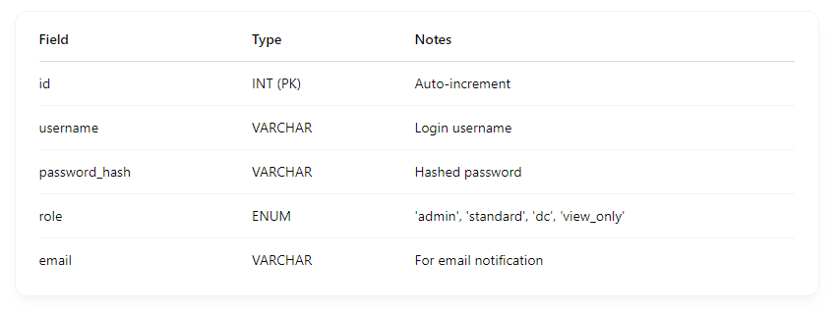

**2. assets**

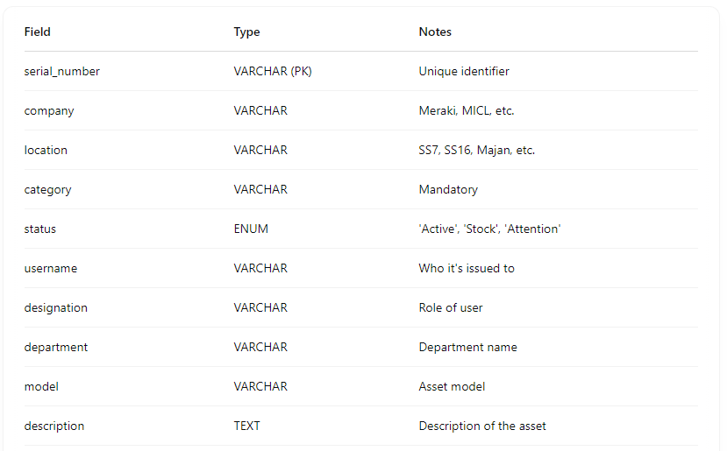

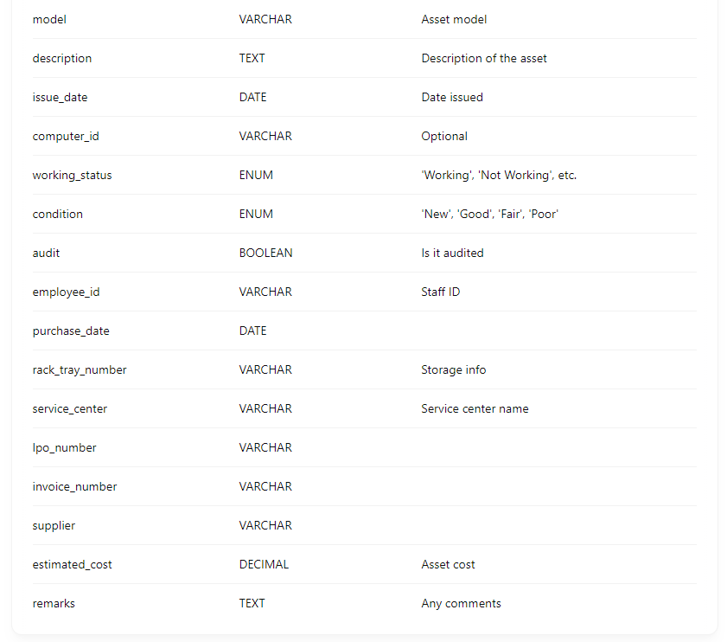

**3.asset_logs (History and audits)**

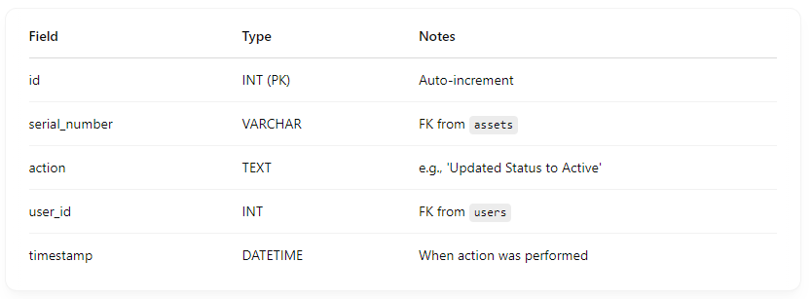

**4.backups**

